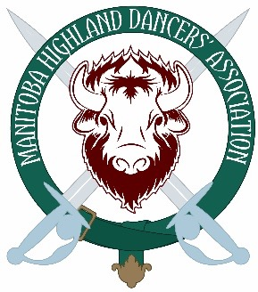
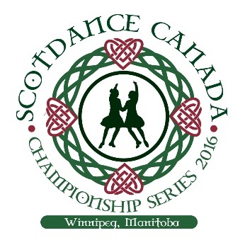
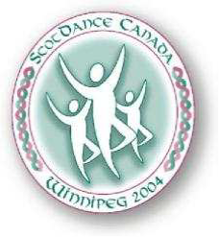

ScotDance Canada Championship Series 2004 & 2016 Scholarships

Two $500 scholarships will be awarded annually from the ScotDance Canada Championship Series 2004 Scholarship Fund, that was supplemented again after 2016.

PrePremier Eligibility:
- An applicant (parent/guardian) must hold current membership of Manitoba Highland Dancers’ Association in good standing for the year of application.
- An applicant must be a Manitoba resident
- An applicant may only win the award once as a PrePremier, but may reapply each year until selected, if they have not previously won and may apply again once reaching Premier.
- An applicant should be intending/attempting to attend SDCCS in the year of application.
- Dancer must be dancing in Pre-premier classes at SDCCS in the year of the application.

Purpose:
To encourage a promising pre-premier dancer to strive for excellence. This award is to assist them to attend the ScotDance Canada Championship Series in order to help give them the wonderful opportunity to experience both the competitive and social events at the Championship Series and to help prepare and encourage them to strive to attend the Championship Series in future years.

Premier Eligibility:
- An applicant (parent/guardian) must hold current membership of Manitoba Highland Dancers’ Association in good standing for the year of application.
- An applicant must be a Manitoba resident
- An applicant may only win the award once as a Premier, but may reapply each year until if they have not previously won (excluding winning as a PrePremier)
- An applicant should be intending/attempting to attend SDCCS in the year of application.

Purpose:
To recognize a Premier dancer that displays the spirit of the 2004 & 2016 Championship Series. This would be a dancer that displays not only competitive spirit, but also community spirit and sportsmanship, as well as a love for and dedication to Highland Dance. This award is intended to assist them in attending the ScotDance Canada Championship Series and to experience both the competitive and social events at the Championship Series.

Selection Process:
The selection will be based upon the dancer’s participation in and contribution to the highland dance community of Manitoba. This would include participation in competitions, dance-outs, Folklorama, volunteer work with MHDA and any other community events that help to promote Highland Dance. Success in competition will be one factor, but participation, as outlined above, will be more highly weighted.

The Selection Committee:
The panel will be comprised of representatives from the MHDA, ScotDance Manitoba and the SDCCS 2004/16 Steering Committee, plus an individual from outside of the Highland Dance community. Note: Any member of the selection committee will excuse themselves if they have a relative or dance student applying.

Award:
The award will be in the amount of $500 annually and may be used towards any dance related expenses.

Application Process:
- Dancers wishing to be considered for the award must meet the above eligibility and complete the attached application form, including an essay of no more than 1,000 words.

- Submit your application form and essay no later than April 15th, 2023 @ 11:59 pm by e-mail to:
scholarship@mbhighlanddance.com

- Please note, only electronic applications will be accepted. Please do not mail, courier or hand-deliver any applications.

- The scholarship winner(s) will be announced at Manitoba Closed Competition and Championship on May 6, 2023.

- The committee reserves the right to withhold awarding either of the Premier or Pre-Premier Scholarships should a suitable candidate not apply.

ScotDance Canada Championship Series Scholarship Application

Deadline: via email only to scholarships@mbhighlanddance.com no later than April 15th

Dancer’s Name: | Dancer’s Date of Birth:
Dance Teacher: | Classification as of Apr 15, 2023:
Address: | City & Postal Code:
Email address: | Phone Number:
# of years taking lessons: | # of years competing:
MHDA membership # | RSOBHD dance card #

Please indicate with an X all the local competitions attended over the past 5 years:
MB Closed Competition (Provincial selection meet in May) __2018, __2022
Mid Canada & Lord Selkirk Premiership (June) __2018, __2022
Manitoba Highland Gathering (Selkirk in June) __2018
Irene Baird Memorial Competition (SDM Oct) __2022
MHDA October Competition __ 2018 ___2019, __2021, ___2022
MHDA November Competition __2018 __2019, __2021, ___2022
MHDA January Closed __2018, __ 2019 __2020 , ___2023
Winnipeg Scottish Festival __ 2018 __2022, ___2023
MHDA March Open ___2018, __2022, __ 2023
SDM April Open ___ 2018
List the specific MHDA dance outs and online dance challenges and virtual workshops attended in the past Four years (not including Folklorama):
List any other dance outs attended in the past four years (with dance school or other organizations)
Folklorama – outline the involvement of the dancer (please be specific about # of days/shows danced, which pavilion(s), with MHDA, Ena Sutton or other):
List of dance awards and accomplishments in competition, medals tests and other:
List any activities relating to promotion of Highland Dance, Scottish Culture and Heritage:
List any of the dancer’s volunteer work with MHDA:
List any Parent’s involvement with Highland Dance, aside from required 2 volunteer shifts (Folklorama, MHDA executive, MHDA Committees, extra volunteer shifts, SDM, SDCCS, etc.):
Please attach your essay outlining why Highland Dancing is important to you. How has it affected your life? Why do you feel you should be considered for this scholarship? (Not more than 1000 words please)

